**Puget Fence LLC Web Design Client Questionnaire**

1. **Please provide your full name and your full contact address below:**

**Ben Stoican**

**9195 SE Overaa Rd.**

**Port Orchard, WA. 98367**

1. **Please provide you contact phone number and email address:**

**360.509.5095**

**pugetfence@gmail.com**

1. **Briefly describe your business, and your background in fence building:**

We are local company based out of the Kitsap Peninsula and have over 15 years of experience in the fence industry. We strive for excellence in all we do. Specializing in all types of fencing, such as:

-Chain link, both galvanized and vinyl

-All types of Cedar Fence (including custom design)

-Vinyl Fence

-Aluminum

-Ornamental Iron

-Agricultural Fence

-Split Rail

We also, build decks to specification:

-Composite

-Cedar

-Treated

-Waterproof

No job is too big or too small. Both residential and commercial.

1. **Any Warranty on the material or your workmanship?**

**One year labor warranty. Some manufactures provide warranty on some materials.**

1. **Areas you are serving? Check the list below: (Also add any that I have missed)**

• Seattle   
• West Seattle  
• Bellevue  
• Mercer Island

• Vashon  
• Port Orchard  
• Bremerton  
• Gig Harbor

• Belfair  
• Bainbridge  
• Silverdale  
• Tacoma

• Whidbey  
• Port Townsend  
• Camano Island  
• Shelton

• Fremont  
• Ballard  
• Bothel  
• New Castle  
• Kent  
• Auburn  
• Tukwila  
• Des Moines  
• Burien  
• Sea Tac  
• Renton  
• Federal Way

-Everette

1. Why should people do business with you rather than your competitors?

Because Puget fence offers the best possible customer experience. Our rates are fair and competitive. We take the time to find what it is the customer wants and provide best possible options for the budget. Puget fence is a company that believes business is built upon relationships and through those relationships, you’ll find that we are a company you can trust.

1. Describe the style of the website you want.

**I like the Alpine website. It simple and gets the point across.**

1. **Who are your competitors? Please provide their website url and what do you like or don’t like about their website?**

**Here is a few I have found:**

<http://www.alpinefenceco.com/>

<http://www.citywidefence.com/>

<http://www.economyfence.com/>

1. Do you have specific company colors that need to be used? I have few initial selections below: please check the ones you feel like it is a good fit. Or certain color that you would really like to incorporate. This is just initial study, these colors selection won’t be the final selection yet.

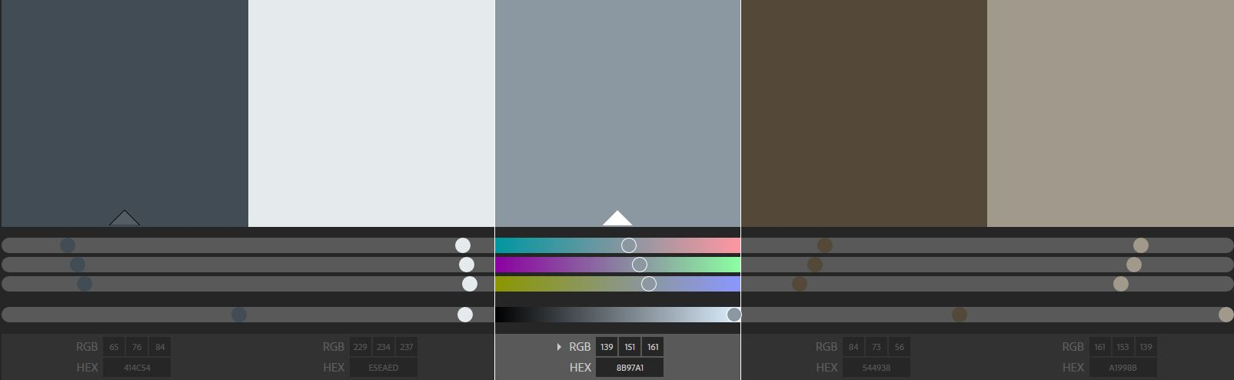

Maybe throw some green in there.

1. What types of things do you see on other websites that you really hate?

na

1. Name the 3 things that are most important in the design of your new website.
2. Ease of navigation 2. 5 tabs on the site with (messages, online quotes, gallery, etc.)
3. Do you already have a URL you plan to use? (please provide the full address)

www.pugetfence.com

1. Would you like us to design/redesign a logo for your company?

**Possibly. I’m open to it.**

1. **Would you like me to re-do your facebook page,** business cards, brochures… etc? (If so we can discuss further later)

What can be done that has been already?

1. Do you have a tagline you wish to use or do you need help creating one for your site?

?

1. How many pages will the finished website be (estimated)? 3-5
2. ? WHA?
3. Will there be any cross promotion of content within the site?

Nah

1. Do you have any specific photos you plan to use? ( We will talk about this further in our next conversation)

I have a lot of photos

1. Will video or audio be a part of the new website?

Not at first.

1. Do you require your site to be mobile friendly (responsive design)? I am planning on doing it unless if you absolutely don’t want to.

Yes. Because mobility is the future.

1. Will you need a form for budget pricing? (If yes, We will discuss this further)

Maybe.

1. How do you want the submitted form info handled? (email?)

Yes

1. Will you need an events calendar feature?

No

1. What information must be on the home page?

What we are about. Some pictures, contact info, online estimates, etc.

1. What information must always be visible?

Contact info

1. Do you have any other specifications or need specific functionality that has not been addressed?

No

Here are some Initial pages/ sections of the website: Check the ones you feel you absolutely need and cross out the ones you don’t want to be part of you website. If you don’t feel towards either way, just leave it.

**Basic:**

Home +

About (Us)+

Services +

Materials

Contact (Us)+

News

FAQs

Links

Resources

Bio(s)

Site Map

**Special Features:**

Video

Image Gallery+

Portfolio

Testimonials+

Quotes

Newsletter

Also have a contractor seal of approval that I will attach to the site as well.